**LAB REPORT NO 7**



**Spring 2020**

**CSE102L Computer Programming Lab**

Submitted by:  **Muhammad Ali**

Registration No. : **19PWCSE1801**

Class Section: A

“On my honor, as student of University of Engineering and Technology, I have neither given nor received unauthorized assistance on this academic work.”

Submitted to:

**Engr. Abdullah Hamid**

(July 16, 2020)

Department of Computer Systems Engineering

University of Engineering and Technology, Peshawar

**1. Print 1 to 100 in C++ using recursion.**

#include<iostream>

using namespace std;

int nat(int n);

int main(){

int n=100;

cout<<"Natuaral number from 1 to 100 is\n"<<endl;

for(int i=1; i<=n; i++){

cout<<" "<< nat (i);

}

return 0;

}

int nat(int n)

{

return (n);

}

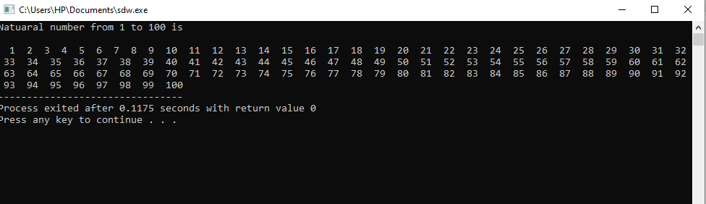

**2. Write a C++ program where you take two values from user if the user enter one or two of**

**the values zero instead of passing the zero values to the function let the function calculate**

**default values if user enters values other than zero pass them to function and calculate**

**their sum.**

#include<iostream>

using namespace std;

int sum(int x = 3, int y = 6);

main() {

int a, b;

cout<<"Entre a number";

cin>>a;

cout<<"Entre another number: ";

cin>>b;

if((a==0)&&(b==0)) {

cout<<sum();

}else if((a==0) || (b==0)) {

if(a==0) cout<<sum(b);

else cout<<sum(a);

}else {

cout<<sum(a,b);

}

}

int sum(int x, int y) {

return x + y;

}

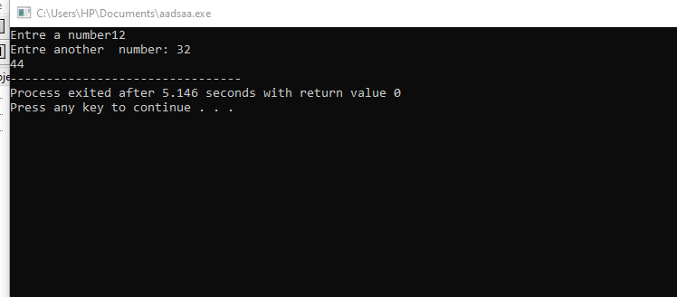

**3. Write a function to find Sum of N natural numbers using Recursion.**

#include<iostream>

using namespace std;

int add(int n);

int main(){

int n;

cout<<"Enter no of natural number\n ";

cin>>n;

cout<<"\nSum of first "<<n<<" natural is ";

cout<<add(n);

return 0;

}

int add(int n)

{

if (n!=0)

return n +add(n-1);

return 0;

}

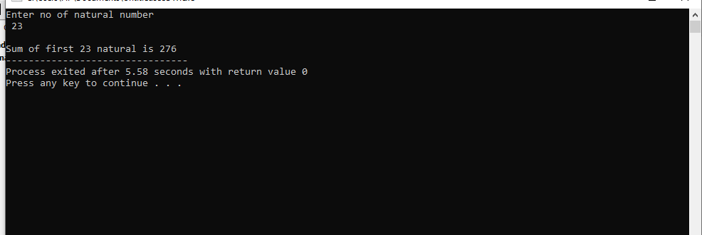

**4. Calculate the sum of odd natural numbers 1+3+5+7+……………. + n using Recursion.**

**Take n as input from user.**

#include<iostream>

using namespace std;

int addodd(int n);

int main(){

int n;

cout<<"Enter number of terms in odd number series\n ";

cin>>n;

cout<<"\nSum of first "<<n<<" odd numbers is ";

cout<<addodd(n);

return 0;

}

int addodd(int n)

{

if (n==1)

return (1);

else

return (addodd(n-1)+(2*n-1));

}

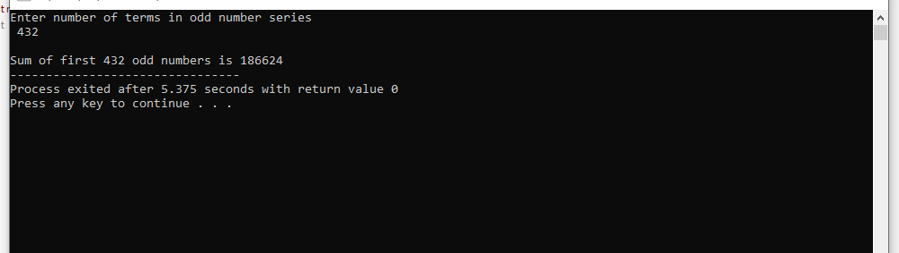

**5. Overload three functions with name grade() one function should accept marks(int) and**

**output the percentage and the other function should accept the percentage(float) and**

**display the grade based on the percentage from previous function finally the third**

**function also named grade should make a call to these other two functions**

#include<iostream>

using namespace std;

int marks;

void grade();

float grade(int a);

char grade(float b);

main() {

cout<<"Enter numbers: ";

cin>>marks;

grade();

}

float grade(int a) {

float p = (float) a/1000;

p*=100;

return p;

}

char grade(float b) {

if(b > 90) {

return 'A';

}else if(b > 80) {

return 'B';

}else if(b > 70) {

return 'C';

}else if(b > 60) {

return 'D';

}else if(b > 50) {

return 'E';

}else if(b > 40) {

return 'G';

}else if(b > 30) {

return 'Z';

}else {

return 'F';

}

}

void grade() {

float per = grade(marks);

char gr = grade(per);

cout<<"Percentage= "<<per<<"\ngrade="<<gr;

}

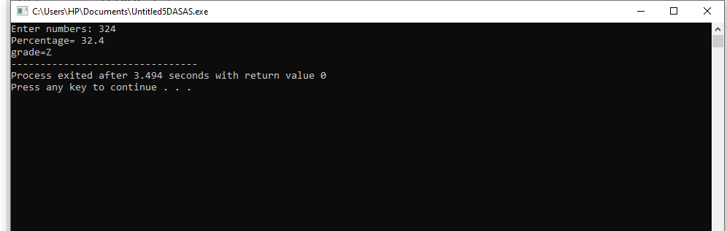

**6. Write a C++ Program to Find Factorial of a Number Using Recursion.**

#include <iostream>

using namespace std;

//Factorial function

int f(int n){

/* This is called the base condition, it is

* very important to specify the base condition

* in recursion, otherwise your program will throw

* stack overflow error.

*/

if (n <= 1)

return 1;

else

return n*f(n-1);

}

int main(){

int num;

cout<<"Enter a number: ";

cin>>num;

cout<<"Factorial of entered number: "<<f(num);

return 0;

}

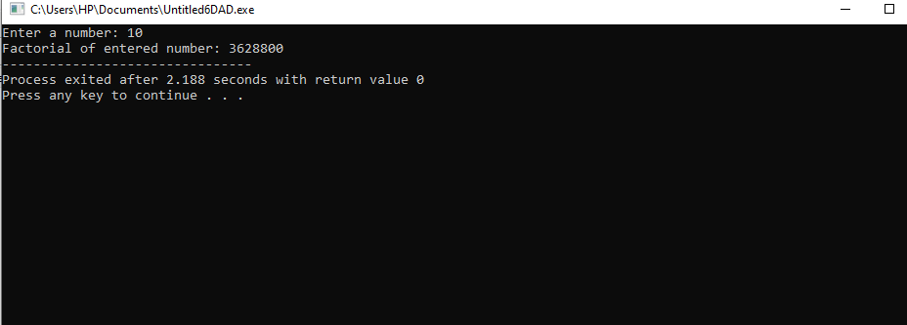

**7. C++ Program to Find L.C.M Using Recursion.**

#include <iostream>

using namespace std;

int lcm(int x, int y) ;

int main(){

int x,y;

cout<<"Enter two numbers\n";

cin>>x>>y;

cout<<"LCM of "<<x<<" and "<<y<<" is equal to "<<lcm(x,y)<<endl;

return 0;

}

int lcm(int x, int y){

static int m=0;

m=m+y;

if((m%x==0)&& (m%y==0))

{

return m;

}

else{

return lcm(x,y);

}

}

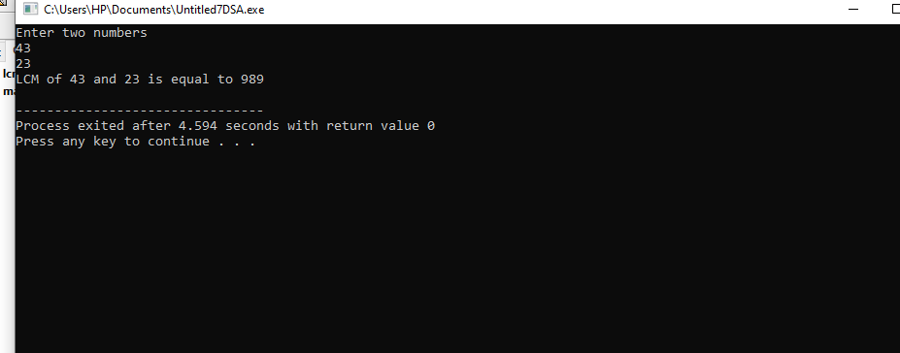

**8. C++ program to print Fibonacci series using recursion.**

#include <iostream>

using namespace std;

int fabo(int x) {

if((x==1)||(x==0)) {

return(x);

}else{

return (fabo(x-1)+fabo(x-2));

}

}

int main(){

int x;

cout<<"Enter term of fabonacii series\n";

cin>>x;

cout<<"Fabonacii series is :\n";

for(int i=0; i<x; i++){

cout<<" "<< fabo(i);

}

return 0;

}

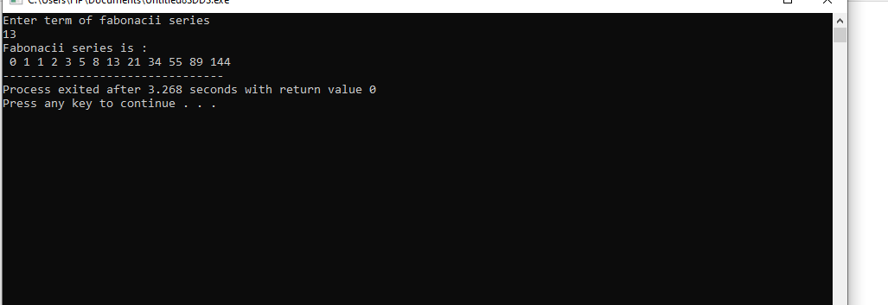

**9. C++ program to calculate power of a number using recursion.**

#include<iostream>

using namespace std;

int pow(int n ,int x);

int main(){

int n,x;

cout<<"Enter a number\n ";

cin>>n;

cout<<"Enter a number\n ";

cin>>x;

cout<<n<<"^"<<x<<" = ";

cout<<pow(n,x);

return 0;

}

int pow(int n ,int x)

{

if (x==0)

return (1);

else

return n*pow(n,x-1);

}

